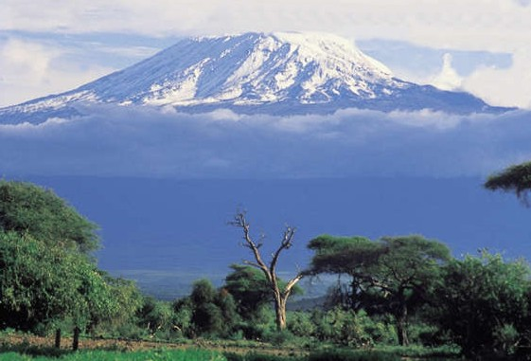

From the Roof of Africa

Sisters of Notre Dame
Holy Spirit General Delegation

May 2017 Newsletter Volume 9 #3

Jubilee Bells are ringing!

Buseesa - 1995
Jubilee bells are still ringing as we begin to share about our first foundation in Buseesa, Uganda. The annals read: The first four sisters: Sisters Mary Janet Stamm and Delrita Glaser of Kentucky and Sisters Jane Marie McHugh and Margaret Mary Scott of California arrived at Entebbe Airport on July 13, 1995. They were greeted and welcomed by Bishop Deogratias Byabazaire, retired Bishop Edward Baharagate and a large delegation of Christians from Bujuni Parish and Buseesa Sub-parish. After the initial greetings at the airport, the Sisters were formally welcomed with songs and dances, speeches and a reception at the Leadership Training Centre in Kampala. Unusual for the dry season, it rained torrentially that day. Someone remarked in a speech, ‘When people of honour come in and begin a new work, rain is a sign of God’s work and it will bear great fruit.’

station wagon May 2017 Newsletter Volume 9 #3 Page 2

After a 9:00 A.M. meeting with Bishop Deogratias and Fr. Heinz, head of Hoima Construction Company to plan our first week in Uganda, we went to Inter-service to inquire about their services, to Hoima Construction House to send a FAX and check boxes, to British Airways to file a claim for our
missing box #13, then to various shops in Kampala to get an idea of merchandise available in the city. Due to a lack of water supply in Buseesa, the sisters stayed with the Dominican Sisters of Catherine of Siena in Kakumiro for a few days. The first visit to St. Julie Convent was made in the company of Bishop Deogratias and some of the Dominican Sisters. In the little church, the group sang the ‘Battle Hymn of the Republic’ and prayed through the intercession of the Ugandan Martyrs and St. Julie. The sisters were led in procession from the church to the convent.

The four sisters of Notre Dame moved into St. Julie Convent on Friday July 21, 1995. Since the new pastor, Fr. Insingoma Peter could not yet be there, Fr. Mugisa Aloysius came to stay with the Sisters. Since the rectory was not ready, Fr. Aloysius took up sleeping quarters in the cook’s rooms. The Sisters were happily surprised to find a propane stove and a paraffin refrigerator, appliances they did not expect to be able to have.

The convent was not finished, the garden was not planted as promised and there was basically little food. Luckily the sisters brought some things from the States to hold them over. Their trip to the neighbouring village where they thought they could buy food was not at all what they expected. The basic means of connection was through radio call as there were neither computer facilities nor a computer on hand. The sisters slept in very small areas until the convent wing could be completed. Lanterns were used for light since there was no electricity in the area. The Sisters began teaching in the government school as plans had not been set up for the St. Julie School, nor the site determined, but in all the hardships of this new beginning, the Sisters found a lot of joy and God blessed their strong missionary spirit.
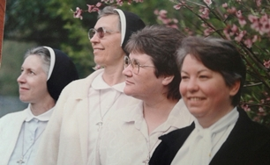
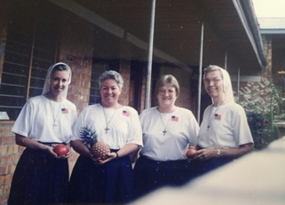

Njiro Formation House
The land for the new Njiro Formation House was purchased in 1996. What a joy it was to begin this new phase of our missionary journey in Tanzania. It was good that Sister Mary Anima was there at the time to bless this new piece of property. Her wisdom and vision enabled the Sisters to finally choose this piece of land to build the formation house. With the added support from Sister Mary Joell, the Superior General at that time, money was able to be secured from the solidarity fund. Sister Mary Joell was so instrumental from the beginning of the mission in Africa. Sister Mary Sujita the new Superior General continued with missionary zeal to help support the growing mission in Africa.

station wagon May 2017 Newsletter Volume 9 #3 Page 3

This was just the beginning of the history of the formation house. Many things came in-between the actual purchase of the land, fencing, planting, making a borehole and many other negotiations before the actual building and move took place in 2001 right before the first Africa Regional Conference.

The annals begin: A Golden Page in the History – The long awaited day dawned for the Sisters of Notre Dame in Tanzania, when we were able to move into a home of our own on African soil. The first day in Njiro began with thanksgiving, joy and excitement. God has been great in his marvelous ways of guiding and directing us to arrive at this day in the history of the life of the Sisters of Notre Dame. The land was bought in 1996 for a Formation House. The dream came true after passing through many challenging realities and events. We are indeed grateful to the Generalate for financing the Formation House construction.

Sisters Mary Kusum and Aruna accompanied the candidates from Ngarenaro for the important day of the beginning in Njiro. The climax of the day was the first Eucharistic celebration in our chapel by Rev. Fr. Morris, a Pallotine Priest. The house was blessed before Mass. Finally we were blessed to have the Blessed Sacrament in our home. The day ended with a Magnificat to the Lord through the intercession of Mother Mary offering the entire building, the formees and all our formation programmes to the Good God.
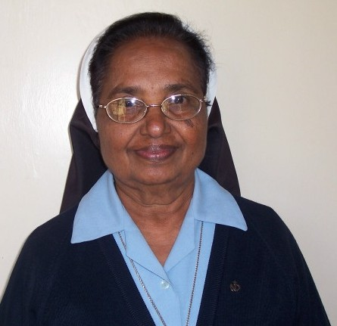
In the following days, Sister Mary Shobana and the candidates worked hard to get the place ready. Sister Mary Shobana along with the candidates found much joy in their hard work of settling the new home for the many that will live in their Notre Dame home in the future. Many things had to be attended to: village meetings, meeting the neighbours, even getting ready for the first Come and See Programme in November and preparing for the arrival of Sisters Mary Sujita and Frances. The candidates prepared the place and a welcome programme with singing and dancing. Sister Mary Sujita cut the ribbon as she entered the new Notre Dame Formation Centre of Africa. As the Sisters moved around, seeing the building, they were moved to tears of joy. They could not believe that such a wonderful structure could come out of that slushy, sticky, black cotton soil.
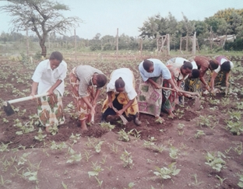
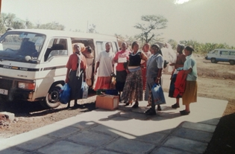

This was only the beginning of a long history over the past 25 years of the many young women who came to Notre Dame and lived in this very formation house. Each of you have your own story to tell and hopefully those stories will continue to be told.

Not long after the opening of the formation house, the Sisters prepared for the first Africa Regional Conference. That too, is part of our history and already five such conferences have been held in several of our African countries: Tanzania, Uganda and Mozambique. May our good and provident God continue to bless our Notre Dame presence and mission among the African people.

station wagon May 2017 Newsletter Volume 9 #3 Page 4

Celebration of Ten Years of the Existence of Aloysia Children, at Zinduka
The celebration of ten years of Aloysia children took place at Zinduka Women’s Centre on March 4th; 2017. About forty-four children attended the celebration. These children are those who live in a difficult environment and are the members of the “Aloysia Children’s” program which meets once each month at the Zinduka Women’s Centre. These children are helped with their education, noon meals and medical needs.

Ten years ago, on February 10, 2007 Sisters Mary Mukti and Rashmi initiated this programme. From 2007 to 2014 Sister Mary Mukti received
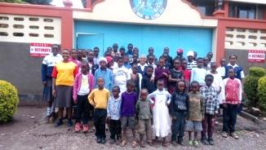
the help of Sisters Mary Rashmi,
Magdalene Mukonyo, Emmah Cindy,
Margaret Mbuba, and Winfred Nduku.
They along with the formees and the
animators nurtured this program. From
2014 to 2016 Sisters Mary Satya and
Kellen have been privileged to work with
the help of other Sisters and the formees
to care for these children.

It was a very well-planned and organized
celebration. Sisters Mary Mukti, Pascalia,
two novices: Sisters Mary Flavia and Mary Mwende along with the Candidates Catherine and Magdaline worked together to plan and prepare the children for the day’s programme. This occasion was graced by the warm, loving presence of Sister Mary Karen from the Chardon Province who represented the benefactors through the SND Chardon Global Missions and Sisters Mary Valerie and Marie Manning in particular. She looks at her own students as future benefactors.
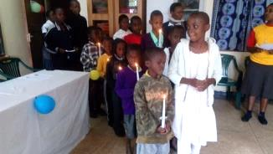
At the start of the day’s event ten children walked into the hall carrying ten lit candles symbolizing the ten good years of their existence. As they walked in and placed the candles on the table, they sang a song to the Holy Spirit in thanks- giving for the guidance for the past ten years. A bouquet of rose flowers was presented to Sister Mary Karen by one of the children as a gesture of welcome and recognizing the effort she made to come all the way to join in the celebration. This was followed by the presentation of songs, poems and speeches by the children. Most of the items were based on the theme of thanksgiving to God for the care, love and support they experienced from God through the Sisters of Notre Dame. The children especially thanked “Uncle Martin and Group”

Sister Mukti shared the History of how the dream of beginning Aloysia Children program was started. We began with 65 children and a good number of them have completed Form 4 and some of them vocational skills. This took all the participants back to the beginnings of this mission. We thank God who placed the seed of this beginning in the minds of our Sisters. This new seed had the support from

station wagon May 2017 Newsletter Volume 9 #3 Page 5

Sister Mary Sujita, the Superior General at that time and was shared by all in the delegation. Sister Mary Mukti thanked all those who have been part of this programme from the beginning, very especially Mr. Martin Schockenhoff and the group “Aktion Arme Welt”. This group continues to support these children’s education, noon meal and medical needs. May our good God bless them. This year we are blessed with 52 children.

During her speech, translated in Kiswahili by Sister Mary Pascalia Ndunge, Sister Mary Karen expressed her gratitude to God for being present for the day. She conveyed many greetings from her students and explained that her children contribute together the little money they get from their parents to help Aloysia children in Africa. She explained to them about the love of God and others. This was a great encouragement to the children. It inspired them to develop love for God who loves every child regardless of where they come from. She was so happy so hear of the progress of the children in their studies and she encouraged them to continue in the same spirit. After a very lively speech from Sister Mary Karen, the concluding prayer was led by one of the Aloysia children. The children were delighted to have the lollipops and the delicious meal prepared by our animators and Candidates which was served for all. All enjoyed the day fully! By Magdaline and Catherine, CND

Welcome to our new novices
In a special ceremony of the Rite of Entrance into the Novitiate, four postulants became novices of Notre Dame. With the theme of “Bread Blessed and Broken” during their intensive preparation, these new novices entered fully into all that their Director, Sister Mary Prerna had planned in their classes, etc.

Nakiito Scovia is now Sister Mary Scovia Nakiito with her feast day on May 31, the Feast of the Visitation of the Blessed Virgin Mary

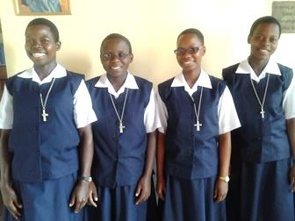
Meet our new novices:

Bingi Rose is now Sister Rose Marie Kusemererwa with her feast day on August 23, the Feast of St. Rose of Lima

From Mozambique:
Aida Manuel Luiz Nhampenza is now Sister Mary Aida with her feast day on August 15th the Feast of the Assumption of the Blessed Virgin Mary. Guida Jenett Teodosio is now Sister Guida Marie with her feast day on September 14, the Feast of the Triumph of the Cross

May God continue to bless our new novices and continue to pray for more vocations in our Congregation and Delegation.

station wagon May 2017 Newsletter Volume 9 #3 Page 6

Simanjiro Grotto

Saturday, May 13th marked a special day in Simanjiro. A special grotto was built in honour of Our Lady and Sister Mary Roshini was privileged to be present for this very great occasion. Sisters Mary Rashmi, Winfred, Veronica and Brigid Marie did much to facilitate this celebration and prepared the children well. Our Christians gathered with the children and the parish priest.

We had the blessing of the grotto of Mother Mary Help of Christians on the 13th of May, the 100th anniversary of Fatima and the Feast of St. Julie! We want to introduce a special devotion to Mary among the Maasai people who are still getting rooted in faith. It was touching to see our students running to the grotto several times to pray to Mother Mary. We want to introduce praying of rosary in our small Christian communities. If anyone can help me, I am on the lookout for a good supply of
rosaries. By Sister Mary Rashmi, SND
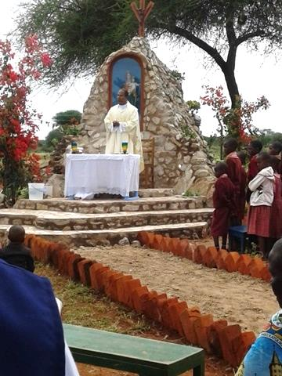
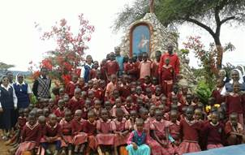

Happy Graduation Day

Dear Sister Mary Roshini and all the Sisters in the Holy Spirit General Delegation,

“Blessed be God the Father of our Lord Jesus Christ, the Father of compassion and God of all encouragement who encourages us in our every affliction, so that we may be able to encourage those who are in any affliction with the encouragement with which we ourselves are encouraged by God.”
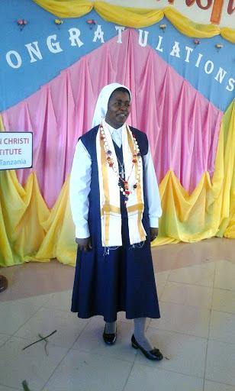
I wish to express my sincere gratitude to you dear Sister Mary Roshini and my Sisters for granting me this opportunity to attend this Course on Religious Formation and Spirituality, for the past eight months. Being at Lumen Christi Institute was of great benefit for me as I was being challenged positively as well as having some help which was part of my journey. Living with 17 of my companions from 13 congregations with different charisms and spirituality was not that easy especially in the beginning, yet as days moved on all seemed to be one as a result of group dynamics, personality theory and self-awareness courses influencing our community and spiritual growth.

wagon Ma 2017 Newsletter Volume 9 #3 Page 7

I wish to acknowledge my appreciation for attending the Graduation ceremony physically as well as spiritually without forgetting to acknowledge those who represented Notre Dame especially Sisters Mary Mukti, Mary Pascalia Ndunge and Mary Teresa.
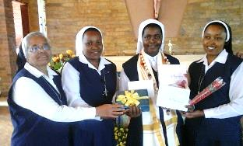

Your presence dear Sisters made me feel loved, cared
for and increased my sense of belonging. You left all
your busy schedules, calling me to avail myself for
others not in words but in actions too.

Coming close to the completion of this course, I wish
to say thank you for the support both physically,
spiritually and materially. The end of every journey is
the beginning point of another. Let us continue to pray for each other. Officially I will complete the course on 23rd of May. Thank you again.
Yours sincerely,
Sister Mary Susan, SND

Coming Attractions!

You will surely want to read with interest our next newsletter which will feature our second celebration of our Jubilee Year. Our first celebration was in our local communities on November 26th the actual date of our arrival in Africa. The next edition will feature a special gathering of representatives of all of our schools in Africa where we minister. Imagine our students from Montessori II to Form 6 travelling to Arusha. We are gathering and housing over 300 students from Tanzania and Kenya as well as some of their teachers in our Notre Dame Secondary boarding facility! Our Sisters in Uganda prepared a special video presentation for this occasion since they could not be present and this will be a great way of joining us in spirit. So don’t forget to look forward to this next great edition.
The newsletter team: Sisters Mary Annete, Shobha and Namita

