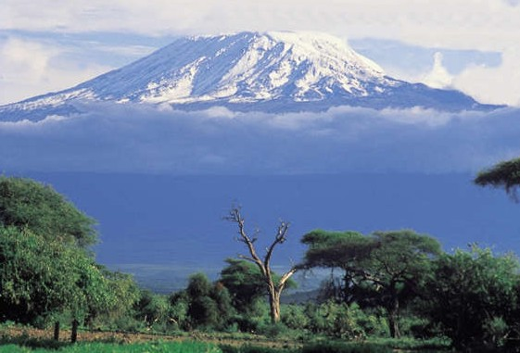

**From the Roof of Africa**

[](http://snd1.org/)

***Sisters of Notre Dame***

***Holy Spirit General Delegation***

***October 2017 Newsletter Volume 9 #6***



**Jubilee Bells are ringing!**

***Syokimau, Kenya 2004***

*It was the dream of Sister Mary Shobana and the Sisters in Tanzania to have a house of our own in Nairobi. Sister Mary Aruna was teaching in Mt. Sinai School owned by the Carmelite Missionaries of Mary Immaculate. Plans were going on and Sister Mary Aruna found a good benefactor to sell his plot to us. With the help of Sister Mary Shobana and the Sisters in Arusha, Sister Mary Aruna went ahead and bought the land in 2003. As it was bought, Sister Mary Aruna planted some trees around the compound and also built the fence. Later in 2004 Sister Mary Anima, the Provincial Superior of Our Lady of Assumption Province in India gave the Sisters permission to have the convent built. In May of 2004 plans were made for the school and convent in Syokimau, Nairobi, Kenya.*

*In June, Sister Mary Roshini was sent to Syokimau to take care of the construction of the school as well as the convent. In July she started meeting the Engineer Casmir to finalize the plans and to get a good Contractor. Finally Manji, an Asian who had many years’ experience with the Salesian Fathers, was chosen as the contractor and began the work.*

*station wagon*  ***October 2017 Newsletter Volume 9 #6 Page 2***



*The dream was actualized on September 8, 2004. On this beautiful Feast of Our Lady, Sister Mary Roshini invited Fr. George Kavungal, CMI to have the ground breaking ceremony to build Notre Dame School and Convent in Syokimau. On October 1, the feast of St. Therese of the Child Jesus the foundation stone of the convent and school was blessed. Sisters Mary Aruna, Shobhita, and Roshini prepared a beautiful prayer service for the day. The neighbours, Casmir our engineer, Manji our contractor, three ND Candidates and some sisters were present for the occasion. By December 4th Sister Mary Roshini had the first interview of the children and January 25, 2005 was the historic day for the opening our Notre Dame School in Syokimau with 12 students. More students came throughout the years and now in 2017 we have 415 Montessori I – Class 3 students.* What a blessing and grace*!*

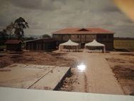

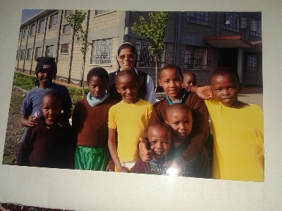

***Zinduka, Arusha, Tanzania 2004***

Sister Mary Rashmi, who has specialized training for Social work and several years of experience in coordinating and directing social work was sent from India and arrived on

April 6, 2002. She joined the Candidates in the formation house on their visits to the villages and teaching the poor children. In addition to this, the annals state that “*Sisters Mary Shobana and Rashmi went to the home of Anna Toli, whom they were considering to employ to help with social work. There was a general awakening among the women in Tanzania regarding the need to work for the development of women. Shortly after her arrival, Sister Mary Rashmi attended a SUAA meeting (Sisters Union of the Archdiocese of Arusha) on the theme of Social Justice. Soon Anna Toli and Sister Mary Rashmi visited 17 houses in the villages. The village leaders were very helpful and the two were introduced to 20 more families by the village leaders.”* In one way, the seed of “Zinduka” was planted and within a few years would give birth.

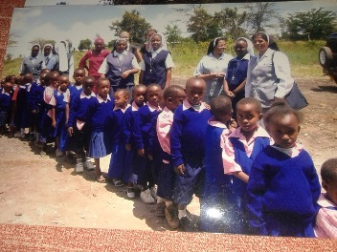

As Sister visited the villages, she noticed many small children not going to school. *On June 29, 2002 the parents of the children who were not going to school were invited for a meeting to discuss sending their children to our Julie School. On July 1st, 2002, Julie School was begun with a full time teacher. There were 24 children in the beginning and slowly the number increased to 59.*

*station wagon*  ***October 2017 Newsletter Volume 9 #6 Page 3***



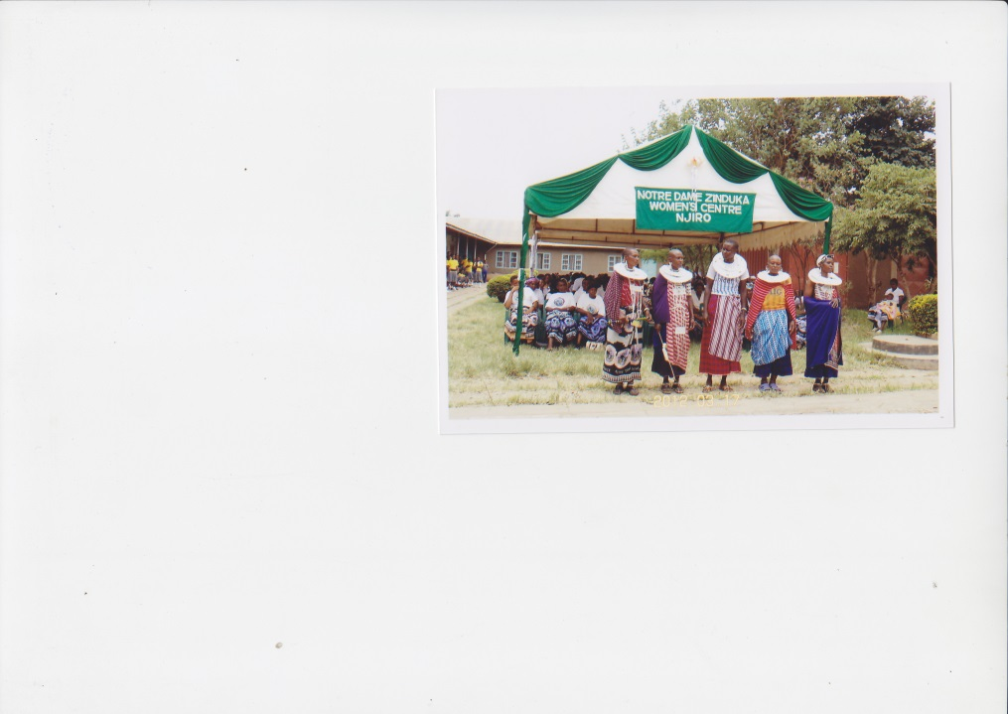

The time came to begin to plan for the future of the

empowerment of women and a message came

from Sister Mary Anima, the Provincial Superior at

that time to meet and prepare a plan for the

Women’s Centre. *There was great interest and*

*involvement of the Sisters in the planning for*

*the Women’s Centre. The building contract was*

*signed on April 10, 2003 with Mr. Cherian and*

*Patel. In the midst of the construction, life*

*continued with the activities with the women.*

*March 8, 2003 was the* ***first International***

***Women’s Day Celebration at Njiro with 140 women present.***

So much happened that it would take volumes to write it all. Planned activities continued, seminars began and village visits were increased. Sister Mary Rashmi walked hours to get to some of the villages to animate the women. Preparations were made for the Inauguration of Zinduka. *March 25, 2004 would ever remain a most memorable day in the history of Zinduka, the Notre Dame Women’s Centre at Njiro Arusha. After the Eucharistic Liturgy celebrated by the Most Rev. Josaphat L. Lebulu, the Archbishop of Arusha, the blessing took place. The Archbishop handed the keys to Sister Mary Shobana after cutting the ribbon and opening the door. On May 9th, 2004 the Sisters began living in their new home at Zinduka.*

***Parents’ Day in Syokimau***

**Rainbow Makes a Promise** was the theme for Parents’ Day this year. What a joyful day it was for all the students, teachers, and parents. The children wore white T-shirts with a nice rainbow painted on them. The chief guest was Fr. Francis Kioko, the Machakos Diocesan Director of Education.

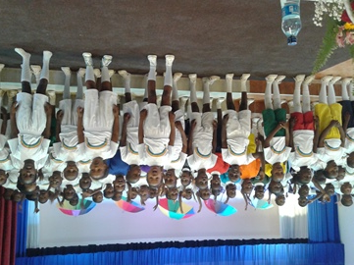

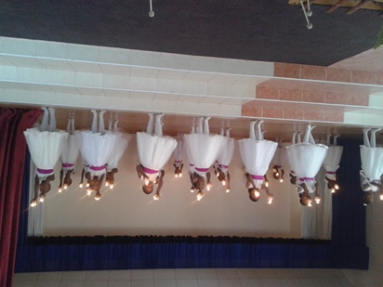

The children presented various items such as songs, poems, played musical instruments in such a beautiful way. The discipline was superb and every person present could see in them the hard work of the teachers. One poem on technology had a very good message especially to the parents to be more aware of how much their children really need and want them to spend more time with them instead of

*station wagon*  ***October 2017 Newsletter Volume 9 #6 Page 4***



being so absorbed in the use of cell phones, iPads, etc. Fr. Francis also called upon the parents to bring up their children in such a way to cultivate good values and especially good

moral values. The chairperson of the school appreciated the standard of our school and the spirit in which the children are taught and brought up by the Headteacher and teachers. The success of the programme came from the hard work of the teachers, the cooperation of all the students from Montessori I to Class 3, the Katangoma group and the constant positive motivation from Sister Mary Namita, our Head teacher. I felt privileged to have been here to help prepare the children and also to witness the presentation.

It was truly a good learning experience for me. *By Sister Mary Winfred Mbatha, SND*

***Jubilee bells ringing in Don Bosco Didia Secondary School***

The long awaited day finally dawned on the 7th of Oct. 2017 which was a day of great joy in Don Bosco Didia Secondary School Shinyanga. It was a day of thanking God and revisiting the history of the school since 1993 and counting the numerous showers of blessings experienced while educating and evangelising the young people of the Shinyanga region. The growth and expansion of the school over the years is really amazing. This growth brings a lot of joy in us since our own Notre Dame Sisters have been a part and parcel of this growth. Amidst the struggles and challenges that the pioneers experienced, it is very evident that the mighty hand of God was, is, and will continue to be upon this great mission of Jesus entrusted to Don Bosco to be continued by his confreres and collaborators.

The launching of the jubilee year started with a solemn blessing that we received through the Holy Mass which was celebrated by Rev. Fr. Mtunga a former head teacher of the school. It was an honour to have him with us. The celebration was also accompanied with several activates such as presentations of the jubilee songs that were composed by our own students of Don Bosco Secondary School Didia.

The Notre Dame Community was represented by our two sisters from our community in Kiomboi, Sisters Mary Kusum and Mary Assumpta and of course all of us here in our Didia community. We thank the two sisters for taking their time to join us in the celebration. Their presence was highly appreciated and Sister Mary Kusum was given the honour to join Fr. Mtunga to unveil the theme of the jubilee that says 25 years of Education and Evangelisation through reason, education, and loving kindness.

The unveiling of the theme was followed by its interpretation and we had an opportunity to hear the short history of the humble beginnings of the school and where the school has reached, now hosting over one thousand students with very great success and achievement of the students that have passed from the school. Later in the evening the students had sports competitions.

*station wagon*  ***October 2017 Newsletter Volume 9 #6 Page 5***





As Sisters of Notre Dame, we are happy and blessed to be part of this great history of Don Bosco Secondary School. We are also grateful that the Don Bosco family trusted us enough to entrust us with the hostel girls as we work in collaboration with them to enrich their mission. Finally as we walk through the jubilee year, we call upon the Spirit to accompany this mission so that the lives of many young people may be touched and transformed.

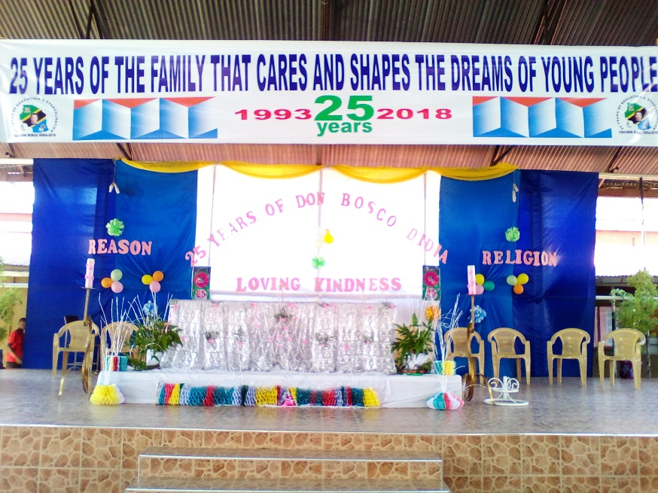



**Another significant day in Don Bosco School**

**October 14**th holds an historical event that happened in the history of Tanzania. It is the day when the people of Tanzania celebrate the death anniversary of Mwalimu Julius Nyerere, the first President of Tanzania. He was a transformational and servant leader who worked hard for the independence of Tanzania. He also helped many African leaders to gain their independence. We were privileged to host Mr. Fredrick Kayombo, Town Human Resource Officer as our Guest of Honour. He helped us to understand why this day is highly appreciated. He also gave us the life history of Nyerere and the relevance of imitating him as the present citizens and non-citizens living in the country and the students who will be the

*station wagon*  ***October 2017 Newsletter Volume 9 #6 Page 6***



future leaders of this country. It was inspiring to know that Mwalimu Julius Nyerere was a man for the people. He fought strongly against corruption, individualism and tribalism that can be a source of conflict and disharmony if not addressed. He also encouraged the Tanzanians to be united by one common language of Kiswahili. In honour of this day our students had different presentations and house competitions including drawing the image of Nyerere, a dressing competition, cultural presentations, and sports competitions. In a nutshell, it was a day to appreciate the nation as a whole and its heritage.

*Written and edited by Sisters* *Mary Christine, Noela and Livia.*

***A Unique Life and Light -giving Community Experience in the Maasai Land***

"Dear God knows everything the best! What he does is well done!” This has been our experience on this sacred soil of Simanjiro. We have truly come to know Jesus, our Good Shepherd. The Maasai people reflect Jesus as they care for and treasure every sheep, goat and cow. They are peace-loving people. This place provided an atmosphere conducive for us to live a reflective life. When there is no rain, the Maasai people seek refuge on the mountain with all their cattle. It is so challenging for them to protect their animals from the wild animals, snakes, etc. They must totally trust in God's provident care as they sleep in the open, in very difficult places.

We had an opportunity to visit this place witnessing it for ourselves. We were privileged to have bit of a “Transfiguration Experience” too. We had Holy Mass on one of the steepest mountains reminding us of the “Transfiguration of Jesus”. We really experienced deep joy and like Peter wanted to remain there.

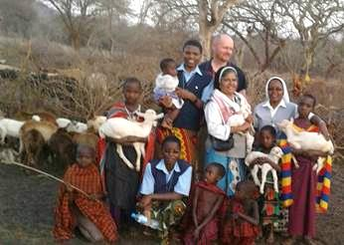

There are some great lessons from the Maasai People. There is a great spirit of sharing and cooperation among the Maasai community!  In any celebration, they gather together and share whatever they have. Even in times of difficulties such as death or when the animals are lost they are united supporting one another. But the Maasai women are not treated as equals. The women are strong in spirit and body. They work very hard, fetching water from afar, searching for fire-wood, collecting grass for roofing, constructing bomas, caring for their family and the animals, besides many other responsibilities.

Our experiences with the faithful have been very enriching. We gather under the trees with these simple people for Sunday services and Small Christian Communities simply sitting on stones. This makes us feel more united with God and God’s people, helping us to grow strong in faith. We have become part of their lives by praying the rosary with them, doing catechesis and joining the choir. When Fr.Albert, SVD came for one week of “Family Evangelisation,”

*station wagon*  ***October 2017 Newsletter Volume 9 #6 Page7***



we were blessed to have Holy Mass every day in our convent and with our people in Small Christian Communities. Fr. Albert taught them

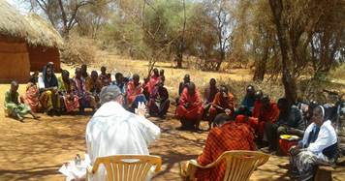

to share the Word of God!  On another level,

we were privileged to reach out to the other

out-stations of our parish as well as our main

parish which has 23 out-stations. Some places

where we went, were 50- 60kms from our

convent. Some faithful don't have anyone to

guide or lead them. Our visits were a source

of joy and hope for them in their faith journey.

Our experience in school with innocent

children has been enriching. The children are

so happy and work hard in their studies in spite of their many challenges. They have to learn Kiswahili and English. They have been trying hard and are coming up with flying colours,

blossoming in this sacred soil of Simanjiro. We also had an opportunity to join TYCS  (Tanzania Young Catholic Students) in Loiborsiret Secondary School for their thanksgiving Mass. We were happy to get this opportunity of joining them in sharing our faith together.

In our community we are blessed with loving and caring Sisters who are always close to us guiding and helping us. We enjoy cooking and sharing other responsibilities. We witnessed the main challenges of the Maasai people which are lack of water, poor educational opportunities, child labour, inequality, forced early marriage and so on. Young girls are given to old men in exchange for cows. Wild animals also attack the cows and spoil their crops leaving the people with less than they hoped for.

Our community experience has truly been blessed and our hope and dream is that as our Sisters reach out to these people, they will be transformed, bring about justice, that children will be educated, and women will have a voice.

*By Sister Maria Domingas and Sister Mary Julitha, NND*

***Congratulations!***

October 24th marked another milestone in the life of Sister Magdalene Mukonyo. Receiving her Diploma in Education from Africa Nazarene University was a joyous occasion for her over1,000 students. Sister Mary Roshini accompanied Sister for the celebration and Sister radiated a joy for achieving this level. Sister was challenged by continuing her studies during holiday classes while at the same time fulfilling her responsibilities as a teacher at our Notre Dame School in Kiomboi and being an active Director of our Aloysia Home. Sister always came from Tanzania to Kenya for her studies with a joyful heart and eager spirit. We wish her all the best in her future studies.

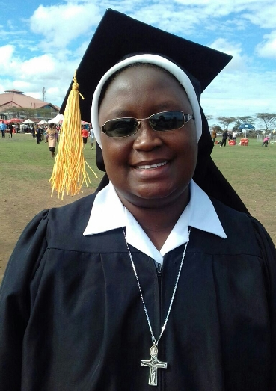

*station wagon*  ***October 2017 Newsletter Volume 9 #6 Page 8***



*We now bring our 6th Jubilee newsletter to a close and you can look forward to #7 in November. It will highlight our last three convents and ministries in this Jubilee Year. We hope that you have enjoyed this journey with us this year as we are bringing our Jubilee*

*celebration to a close on December18, 2017. Who knows what the next 25 years will bring. All we know is that those years will be filled with new life, new hope and continuing ways to*

*make our good and provident God known and loved in our communities, our ministries and our efforts toward Evangelisation.*

*From our newsletter team: Sister Mary Annete, Shobha and Namita, SND*