Fivefold Blessings! Rome, Italy

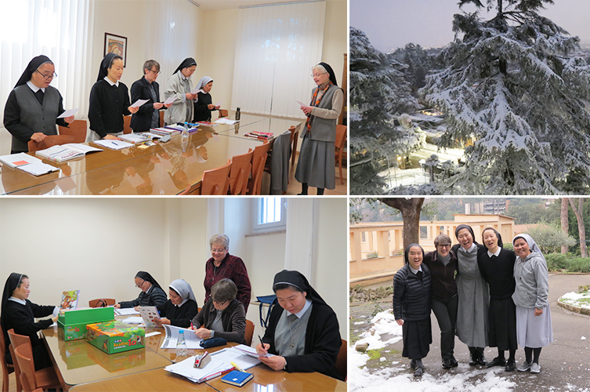

The month of February 2018 brought fivefold blessings to the Motherhouse community as, for the fifth consecutive year, we welcomed five English language students. They have already begun the classes with their instructor, Sister Maria Josefa Cramer, an experienced English language teacher. Sister Mary Ann Culpert, the coordinator of the program, is also assisting the students during these ten months of intensive study.
The students will also take this opportunity to explore Rome and its surroundings and to appreciate their life in the international community at the Motherhouse. We wish blessings on their studies and many more surprises in the Eternal City. The first surprise was the unexpected snow fall that greeted them on Monday morning, February 26.

