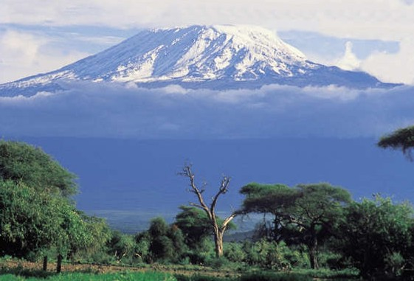

**From the Roof of Africa**

[](http://snd1.org/)

***Sisters of Notre Dame***

***Holy Spirit General Delegation***

***November 2018 Newsletter Volume 10 #3***

***General Conference Participants Arusha, Tanzania***

***September 27 – October 24, 2018***

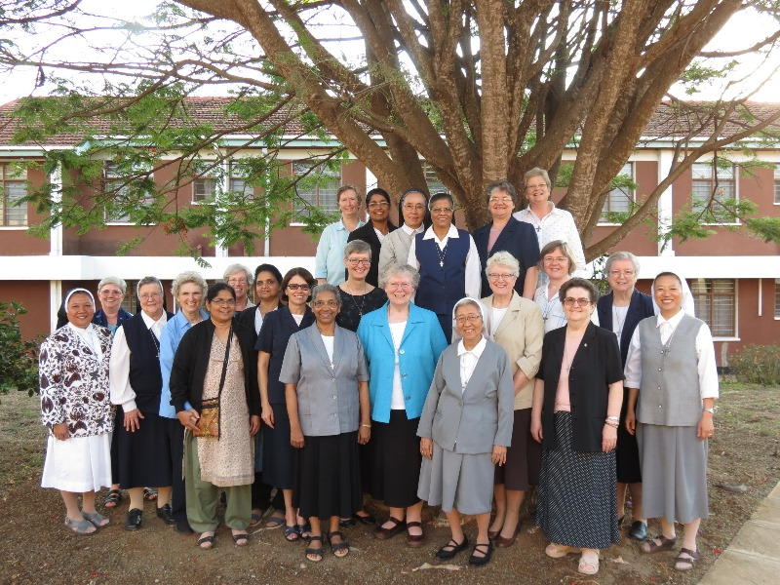

***What a wonderful celebration of our internationality***

***and a “month of intercultural living together, together.”***

As we move together in the coming months, you will be hearing much about the experiences of the General Conference participants. This was a graced time to be together as a Notre Dame family across the world.

*station wagon*  ***November 2018 Newsletter Volume 10 #3 Page 2***



***Some General Conference Memories***

In our Syokimau community we were happy to welcome Sister Mary Tessy, Provincial Superior from Our Lady of the Assumption Province, Patna and Sister Mary Sandhya, Provincial Superior of the Province of Our Lady of the Visitation. Visiting with the community after the General Conference in Tanzania and Kenya was a welcomed gift to them. Both Sisters had a wonderful opportunity to visit with our Sisters in Kenya and see some of the sites that they had never seen before such as the Giraffe Park, the Elephant Orphanage and the Ostrich Farm. We know that the Sisters felt at home with us and we would say to them “Karibuni tena”…..welcome again.

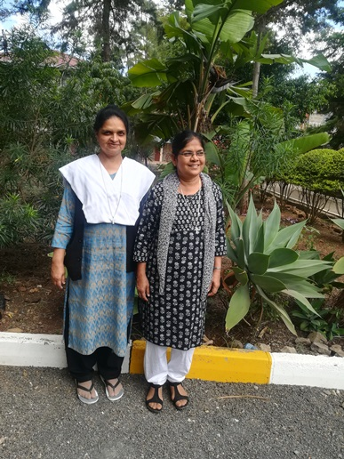

***International Novitiate***

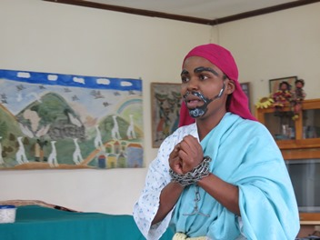

Another opportunity our General Conference participants had was to visit our International Novitiate. “I Paul” was a presentation a few of the novices gave as part of their welcome along with a special programme of singing, dancing, and gift giving. Tea together was an added treat for all of us.

We can hardly contain all that

happened in that month and all the

places the participants visited. Here are a few

more highlights of their visits.

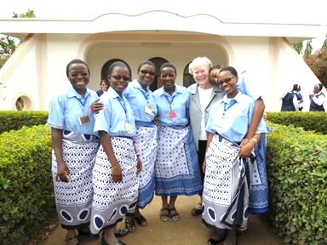

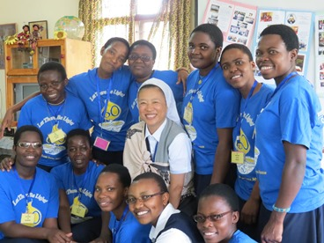

*station wagon*  ***November 2018 Newsletter Volume 10 #3 Page 3***



***Zinduka Women’s Centre***

The long awaited day dawned at Notre Dame Zinduka Women’s Centre on 6th of October. The women arrived very much on time which was unusual. They were excited and eager to receive the Sisters from all over the Notre Dame World.



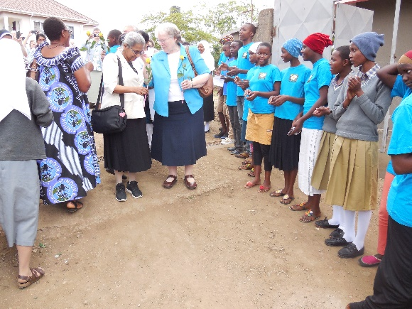

As the sisters arrived from their residence at Canossa Spirituality Centre, the women, Aloysia Children as well as the tailoring girls were all lined up to welcome them. They were received from the novitiate gate with ululations and dancing; each received a flower from the women as a sign of welcome.

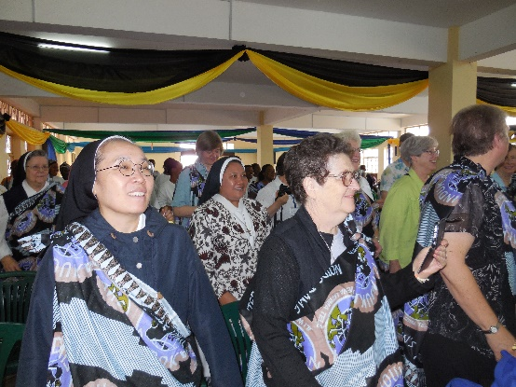



They were led into Lourdes Hall where the welcome and appreciation programme took place

in African style by the women, girls, Aloysia children, and the ND Candidates.

***AT MURIET NURSERY***

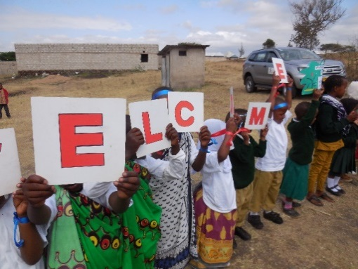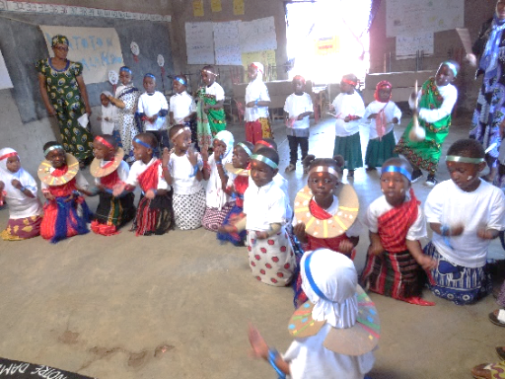On 12th of October was another great day for Zinduka Nurseries. Juhudi Zinduka Nursery was privileged to receive the Sisters at their hall accommodating about 100 of the adults and the children present on that day.

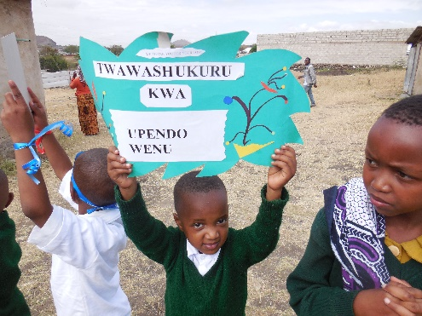

The Sisters and parents present enjoyed the children’s programme. They presented poems, action

*station wagon*  ***November 2018 Newsletter Volume 10 #3 Page 4***



songs and an African dance they had learned from their teachers. The Sisters were impressed at how the children from the interior village were able to bring out their talents and capacities to their best level.

At last the Sisters were given a candle on a stand to signify the light and support they brought to us and how it continues to burn brighter to the rest of the society as hundreds of the children from this nursery school have climbed higher levels of their education.

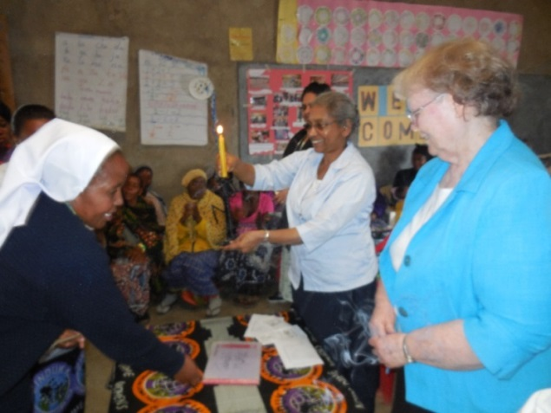

The children were reconized with sweets and a packet of milk by members from the General Conference and they went home happily as the Sisters went to see the old and new road and the bridge down the river.

All in all it was very encouraging to have our Sisters for a village programme exposure and experience what the delegation has placed in our hands through the mission of our congregation here in Tanzania. Thanks to the teachers for their hard work which enabled the children to present the beautiful programme and Sister Mary Margaret who went daily for one week to help prepare the children’s programme as well as Sister Mary Magdalena for her supportive presence on that day. We are grateful to the General Conference participants for their visit, encouragement and support.

*By Sister Mary Kellen SND*

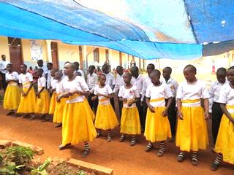

***Simanjiro***

There is just sooooooooo much more we could

write about the wonderful visits to our places of

ministry. Here, some of our students in our Notre

Dame Osotwa School wave a hello to each of you;

capture that look of happiness! The students

presented a programme for all the members of the

General Conference.

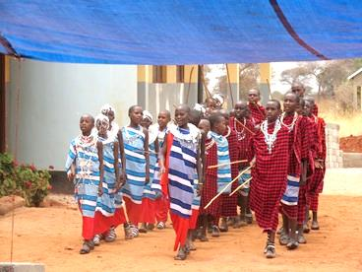

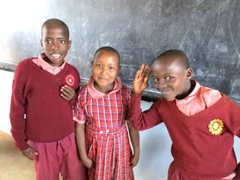

Some presented the traditional Maasai dance in the Maasai dress. From the tiniest child to the Maasai choir, everyone did their best to share with all the participants the meaning

*station wagon*  ***November 2018 Newsletter Volume 10 #3 Page 5***



and value of what it means to be a Maasai. All expressed their gratitude, no matter where the participants visited, for the gift of the Sisters of Notre Dame to their place of ministry, especially the institutions of learning. May our good and provident God bless each one.

Don’t forget to go to the SND website to see the video recaps of the General

Conference and the participants trip to Ngorongoro Crater.



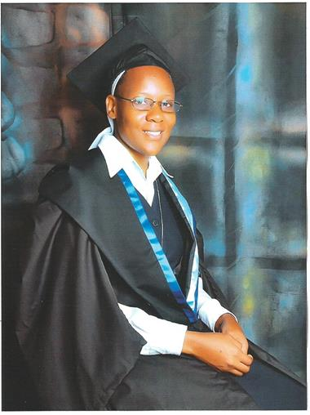

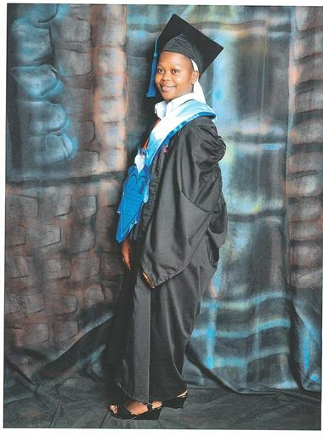

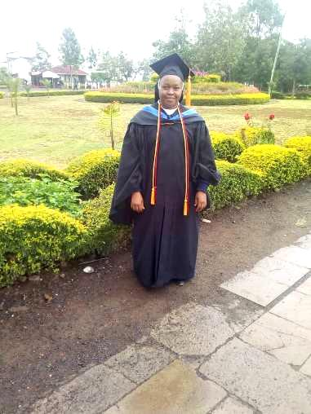

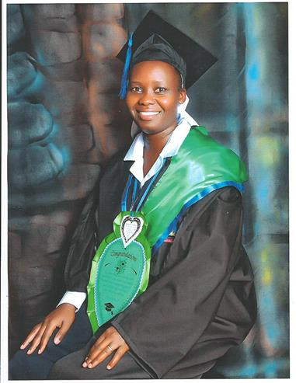

Sister Mary Margaret graduated from the University of Kisubi with First Class Honours and a Bachelor of Science Degree in Family and Child Counseling Psychology

Sister Mary Teopista graduated from the University of Kisubi with Second Class Honours-Upper Division with a B.Ed in Secondary Education

Sister Mary Olive graduated from the University of Kisubi with Second Class Honours-Upper Division with a B.Ed in Secondary Education

Sister Mary Elizabeth received a B.Ed. and

1st Class honours from Africa Nazarene University

*As we bring this newsletter to a close, we anticipate another one coming shortly as we had much to share in these past months, so look forward to a newsletter in December. We already anticipate the coming of the season of Advent and so we wish all of you a blessed Advent.*

*The Newsletter Team: Sisters Mary Annete, Neelima and Namita, SND*