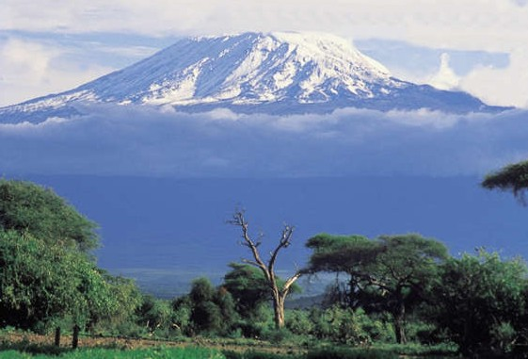

**From the Roof of Africa**

***Sisters of Notre Dame***

[](http://snd1.org/)

***Holy Spirit General Delegation***

***April 2020 Newsletter Volume 12 #1***

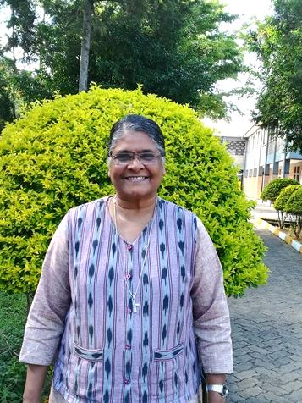

***Sister Mary Shruti, SND***

What a gift and blessing to have Sister Mary Shruti visit us

from India. Actually, her travels were far and wide before

coming to us. Sister Mary Kristin, our Superior General in

Rome, asked Sister to come and teach those in formation in

various mission areas of our Congregation. We were so happy that Kenya and Tanzania were part of her places where she would visit and teach.

Sister had the opportunity to teach our novices for ten days, and then our 31 temporary professed who had gathered for their yearly Junior Get-together. All of those who met Sister, interacted with her and learned from her, were touched and challenged by her total commitment to what she was asked to do…more than 100%! It went beyond that, to her real desire to make the mission of Jesus known and loved. We are grateful to our Superior General, Sister Mary Kristin, for giving Sister Mary Shruti and all of us the experience of learning more about Missiology.

Sister had an opportunity to visit Kenya for a short time and experience life in another part of our Delegation. Hopefully she will come back at some time and also visit our Sisters and formees in Uganda. God bless you, Sister, as you continue your ministry and mission.

*wagon*  ***O April, 2020 Newsletter Volume 12 #1 Page 2***



***Annual Gathering of Temporary Professed Sisters, Tanzania***

With great joy and expectation thirty-one of us began our gathering on December 7, 2019. One student Sister could not be part of this year’s program and three student Sisters could not be part of the retreat. The program started with orientation from Sister Mary Mukti, the Director of the Temporary Professed.

We were divided into four groups and each group had to prepare programs for recreation after supper which were part of our Junior Get-together. All the groups were very creative in their programs. Some groups prepared a program on our theme which made us happy and helped us realize the impact of multi-cultural/cross cultural living.

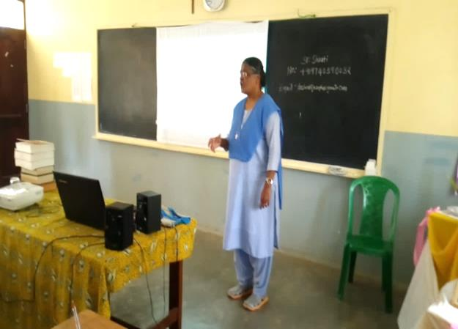We want to send our appreciation to Sister Mary Kristin, our Superior General, and her council members for allowing Sister Mary Shruti to come and present the topic of Missiology. It gave us a wider knowledge and enlightened us on what mission is all about. We learned about experiences and practical activities in community from her own life. These are the things Sister Mary Shruti highlighted: a positive attitude, appreciating each one as unique, valuing the dignity of each one, and valuing other religions and denominations.

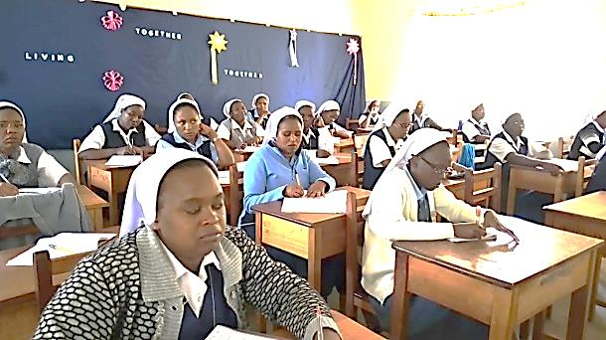

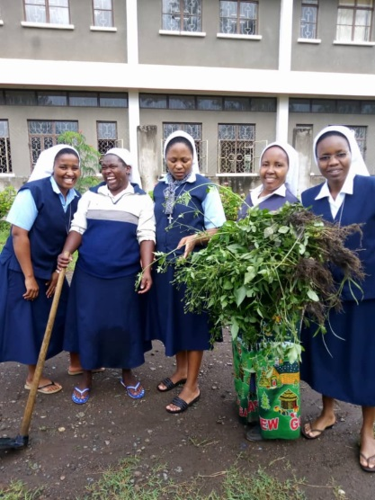We also thank Sister Mary Roshini, our Delegation Superior, for taking her time to come and share with us regarding the characteristics of our Notre Dame culture and what to expect in the next ten years.

The presentations on JPIC by Sister Mary Kellen not

only touched and inspired us, but challenged us to

take care of Mother Earth and be a voice for the of

voiceless, especially for women and children who

are our own employees. The sessions were

concluded by planting various fruit trees in the

formation compound and Zinduka Women’s Centre.

We go forward with a promise to practice what we

learned in our own communities.

*wagon*  ***O April, 2020 Newsletter Volume 12 #1 Page 3***



We are grateful to Sister Mary Kellen for being with us and for being a good promoter of JPIC.

We had our retreat conducted by a Passionist Priest, Father Kilasara Engelbert, on the theme, “Intercultural Living Together-together.’’ It was a quiet time to pray and relax. His presentations were thought-provoking and inspiring. In one of his talks he gave an example of a housefly and a honey bee, challenging each person not to focus on the negative part of our Sisters but to be the honey bee that only takes the best. He also said to have a heart that can forgive and let go, embracing each other’s culture the way it is because there is no perfect culture.

Following our tradition on the 24th of December, we shared our Christmas gifts with the Njiro, Novitiate and Zinduka communities. On Christmas morning, we celebrated the Eucharistic Liturgy at our Holy Family Parish Church. Following this, we cooked festive meals and after supper, we gathered around the Christmas tree to reveal our prayer partner or Advent friend, and exchanged gifts with one another while singing and dancing. December 27th was a day to say thank you to our Junior Director. We had special evening prayers followed by supper, as well as programs by different groups using various cultural dances.

Toward the end our Get-together, we had a picnic. We went to Shanga, a place where differently disabled people work to earn their living. While there, we used the little sign language we knew in order to communicate with some of them who were deaf and mute. We saw how they recycle broken glass bottles into beautiful beads, wine glasses and flower vessels; others weave blankets and table mats and make shawls. We learned that disability is not inability. Anyone can work and earn something so long as they are empowered.

We had another opportunity to visit the Cultural Heritage Centre where we saw paintings, sculptures, furniture and photographs depicting different cultures, animals, and the natural beauty of Africa. The climax of the picnic was a delicious meal arranged in a small restaurant.

Once again we express our thanks to all the local superiors for the surprises sent for us, and to all Sisters in the communities who took on our responsibilities while we were away. With joy in our hearts, we want to say a big thank you to Sister Mary Mukti for organizing the Get-together program. We look forward to the gathering next year and welcoming our new Juniors.



*By Sisters Anita Marie and Mary Jescah, SND*

*wagon*  ***O April, 2020 Newsletter Volume 12 #1 Page 4***



***JPIC Seminar, Tanzania***

It was a privilege for the Novices and Candidates to attend the one-week seminar on Justice, Peace and Integrity of Creation. Sister Mary Kellen’s presentations enabled us to learn the main concepts of JPIC such as the problems faced by refugees, migrants, and the issues of migration. We received new knowledge regarding consecrated life today and its challenges including the crisis of mission and spirituality. In addition, we learned about human trafficking and the crimes associated with those trafficked. Sister brought to our awareness the TALITHA KUM Organization which is working so hard to prevent human trafficking.

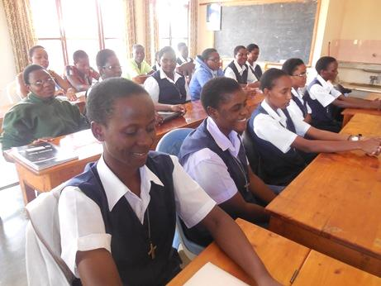

It was our joy to know more about the challenges affecting JPIC, and we realized that we are all called to educate especially the youth. The Novices were divided into two groups; the *See, Judge and Act* group and *Friends of Nature* group. We implemented our new knowledge, for example, by planting and taking care of some pawpaw trees; our animals are also receiving more love and care.

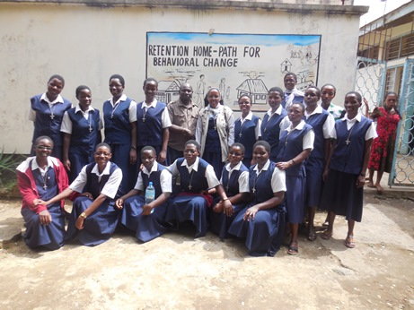

We thank Sister Mary Kellen for granting

us the opportunity to visit the Juvenile Prison Centre. It was our joy to speak to those young boys and girls who are detained due to various crimes. With grateful hearts we promise to share what

we have learned with others.

*By Sisters Mary Jyosita, Neelima and Novices*

***The Pentateuch***

The Novices and Candidates are grateful to Sister Mary Kathleen for teaching The Pentateuch, the first five books of the Bible. We were happy to receive more knowledge and understanding of the Scriptures. We would like to share with you some new insights we had. We came to understand that Noah is the New Adam. After the fall of man,

God did not abandon human beings but he gave us a new Adam to save the people. We

also learned about the significance of Noah’s Sons: Shem who must be the head of all, Japheth who dwelt in the tent of Shem and Ham who was the slave of both.

We came to understand that we are made up of Noah’s sons. Shem represents spiritual aspirations, Japheth, rational and Ham, inclinations. We received more knowledge about The Pentateuch and how it was fulfilled by Jesus in the Gospel. Each book gave us a new awareness of obedience,

*wagon*  ***O April, 2020 Newsletter Volume 12 #1 Page 5***



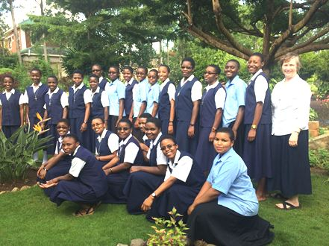

freedom of choice, being humble and not to desire to be like God. Our workshop was a good opportunity to learn and included other activities such as singing and dancing.

We take this opportunity to express our sincere gratitude to Sister Mary Kristin for sending Sister Mary Kathleen to teach and share her knowledge with us. We thank you, Sister Mary Kathleen. and we will remember to be guided by the three sons of Noah.

*By Sister Anne Marie, NND*

# *Zinduka Women’s Centre Celebrates the Elderly*

More than 200 elderly people were fed and given various gifts at Zinduka Women’s Centre, Njiro, Tanzania. Added to this, 50 others had their gifts reached them since they could not come for the celebration due to the challenges of old age.

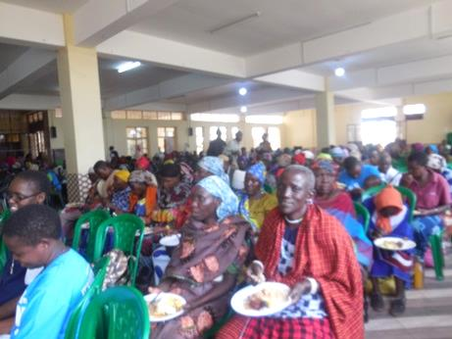

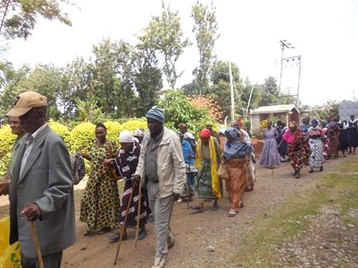

The day had been planned since last year. The women leaders and women’s groups had the responsibility to secure a list of all the elderly 70 years and above regardless of religion, tribe or

gender. Their names and location was identified and suggestions were also given as to what gifts would be given. It was finally decided that they would get one kilo of sugar, rice, maize powder,

*wagon*  ***O April, 2020 Newsletter Volume 12 #1 Page 6***



millet powder half bar soap and cooking oil. Of the 284 women, all were willing to contribute Tsh.5000/= towards the specific gifts to the elderly. This was a great support for the 250 elderly people. The Centre managed to get Tsh. 320,000/= from the people of good will and some gave clothes as well.

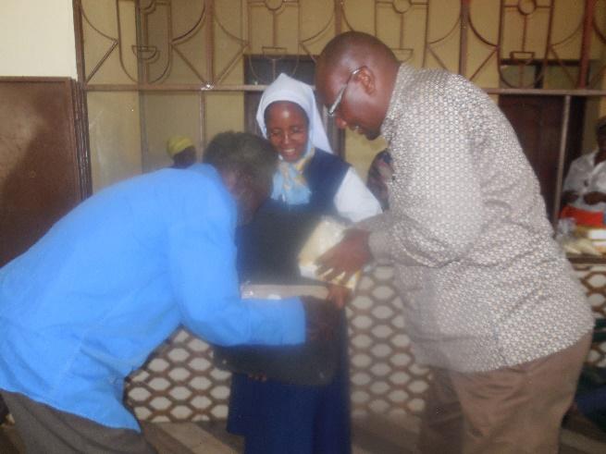

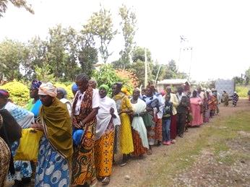

The food and some others gifts were supplied from the Centre. The old people as far as from Mkono, Lemara, Olkerian, Engosheraton, Kikwakwaru and Njiro were present. As part of the agenda of the day, various groups were there to welcome and entertain them. Mr. Naboth Paul Silas from Lemara was the one and only visitor who came and remained for the distribution

of the gifts to the old people. He promised to contribute Tsh. 50,000/= for the monthly visit to the elderly for six months from March.

All in all, it was a gracious day. The old people were graced and blessed. The leaders and the helping sisters all did their role very well. The women would share later how they received many blessings from the elders they visited and gave the gifts; those who could not come. We thank God for everything. We look forward to the Women’s day celebration. *By Sister Mary Kellen, SND*

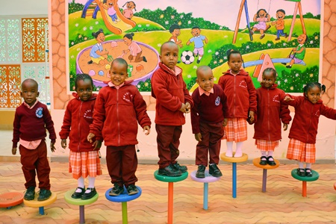

***House of Children, Kenya***

The new changes in the curriculum in

Kenya required the addition of classes

4, 5, and 6 in our school. In order to

accommodate all the students who

would be part of this new set up,

Sister Mary Namita, the Head Teacher,

visualized what a “House of Children”

would look like in order to educate the

youngest members of the school. As a

result, the House of Children was born!

This new building, on the same property

as our school for classes 1-6 will, according to the new curriculum, be for the Play School and Pre-Primary I and II basically our 3-6 year olds. With the assistance of our Delegation Superior, Sister Mary Roshini and Mr. Babu our contractor, the supervisor and workers, this building was ready for occupancy in January, the beginning of our new academic year.

*wagon*  ***O April, 2020 Newsletter Volume 12 #1 Page 7***



Our Head Teacher, Sister Mary Namita outdid herself as she helped supervise, give ideas and helped create this beautiful, not just “House of Children” but a real home for the children. The whole atmosphere is so inviting. Sister made hundreds of trip to the building showing new parents all the wonderful assets of this unique place of learning. The beautifully painted pictures throughout the building and classrooms makes the children feel they are in a world of wonder and excitement to learn. Their enthusiasm and joy in learning is contagious!

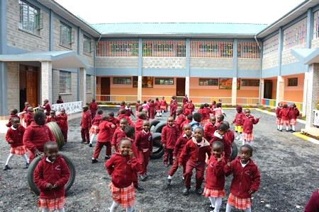

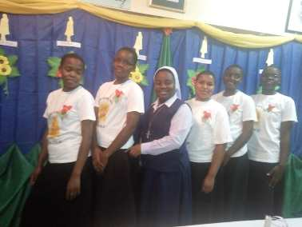

***New Pre-Postulants in Tanzania***

Welcome to our new pre-postulants

in Tanzania. Sister Mary Noela, their

Formator, prepared them. We know

that all those on this part of their

journey will receive much help as

they prepare for the

next step

.

*We hope you enjoyed the first edition of our Newsletter for 2020. We want to thank Sister Mary Neelima who has been part of the Newsletter Team for the past few years and for her wonderful proofreading skills. We want to introduce to you Sister Mary Teopista who will be the new member on the Newsletter Team. We hope you enjoyed reading this Newsletter and encourage you to look forward to the ones that will come in the coming months.*

*We join as global citizens to pray for our world-wide health crisis of the coronavirus. Let’s join together in praying for our health care professionals, governments and world leaders in their efforts to curb the spread of this coronavirus. We ask our good and provident God to extend the healing touch to all who have lost their loved ones.*

*From you our newsletter team: Sisters Mary Annete, Neelima, Namita and Teopista, SND*