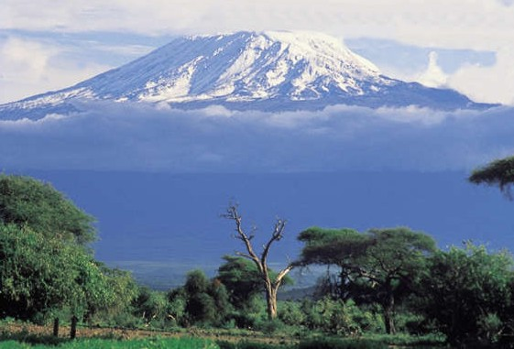

From the Roof of Africa

Sisters of Notre Dame
Holy Spirit General Delegation

July 2020 Newsletter Volume 12 #2

Part II Special Edition

25th Anniversary of Arrival in Buseesa, Uganda

The first part of our July 2020 newsletter, ended with the introduction to Sister Mary Margaret Droege’s book on the history of Uganda. It seemed fitting to extend our newsletter into Part II as July 13th marked the 25th Anniversary of the arrival of our Sisters in the new mission in Uganda.
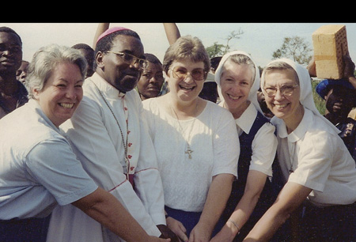
It all began so many years ago with an
invitation, a dream, and a reality. When the
invitation came to begin a mission in Uganda,
Sister Mary Margaret Droege from the
Province of the Immaculate Heart of Mary and
Sister Mary Amy Hauck from Rosa Mystica
Province accepted it with eagerness and perhaps
a little trepidation. Here was an invitation to
a new country, culture, language and all that
embracing a new mission might entail. But
nevertheless, the invitation was accepted and
the first volunteers were named: Sister Mary
Delrita Glaser and Sister Mary Janet Stamm from the Province of the Immaculate Heart of Mary in Covington, Kentucky and Sister Jane Marie McHugh and Sister Margaret Mary Scott from Rosa Mystica Province in Thousand Oaks, California. And so the story began!

The four Sisters arrived on July 13, 1995 and were greeted and welcomed by the late Bishop Deogratias Byabazaire.

wagon O July 2020 Newsletter Part II Volume 12 #2 Page 2

Sister Mary Margaret Droege, SND in the 25th Anniversary book of the Holy Spirit General Delegation: I’m not much of a risk-taker, so accepting a mission in Uganda took all I had: courage, determination, and above all, trust in God. As the Provincial Superior in Covington, Kentucky, one of the great gifts God gave me at that time was Sister Mary Amy, the Provincial Superior in Thousand Oaks, California. She could be more positive when I felt heavy; she could laugh when things were tense; she saw the big picture and I was more the detail person. We were a good team. We were able to get through: (1) the shock of having to build a rectory before we even began the construction of the convent; (2) the
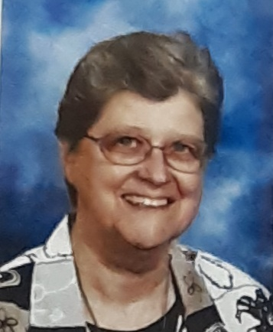
concern about the construction of the convent not even being started when we had set an approximate date for the Sisters’ departure for Uganda; (3) the startling realization of expansive site of the convent when we made our first visit to the Sisters in Uganda; (4) the unbelievable cost of the first vehicle – tax upon tax; (5) the serious illness of two of the Sisters in the first year. God really tested me in the establishment of the mission, but his gifts to me and to our community were endless. I feel so blessed that God gave me to opportunity to participate in a mission.

Sister Mary Amy Hauck, SND wrote:
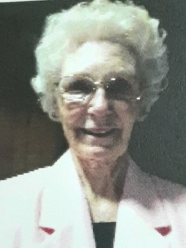
Buseesa was/is always a place of joy. On our very first visit, the people
welcomed us with genuine joy and simplicity of heart. Each time I returned to visit, I sensed this same joy in all the people and in the Sisters. My heart celebrated and I still give thanks.

In 1990 we all heard the call from St Pope John Paul to come together and share what we have with the African continent—one that is so rich in many but
ways, desperately in need of education. Since at the time of the Chapter we shared a
report about how we used our resources, we became aware that education is a major gift/skill we possess. In the end, we realized, as a province, that education is the gift we have that really
makes a significant change in the lives of those to whom we minister. Knowing that we could match our gifts with the need in Africa, we felt that God was calling us to say yes to the request for Sisters made by Bishop Deogratias Byabazaire. Sister Mary Margaret Droege and I, along with Sister Mary Joell Overman, the Superior General at that time,
decided to visit Uganda and check out how we could best be of
service in the Diocese of Hoima.

As Providence would have it, on one of our last days Bishop
Deogratias said we would be visiting Buseesa, in the district of
Kibaale, one of poorest outstations in his diocese. As our vehicle
slowly approached the entrance of the church, the men, women and
children of the village greeted us with songs and cheers and gifts.
For me, it was pretty well love at first sight.

Late in the afternoon when we had returned to the bishop's residence, Sister Mary Margaret and I talked for many hours about the best way that we could help the people of Buseesa and the other outlying mission stations. Finally, we decided on building a model primary school as the first phase. Many challenges would come our way, but we trusted in God’s goodness and divine providence. It is a joy to have been a part of so wonderful a venture. With God all things are possible.

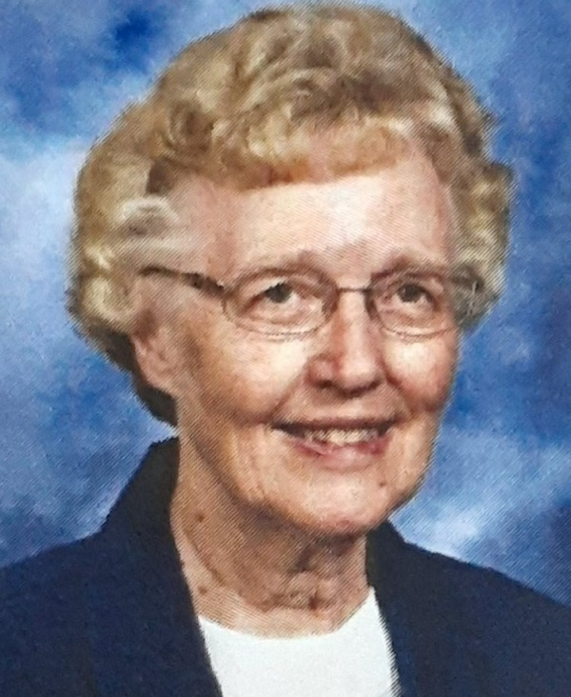

wagon O July 2020 Newsletter Part II Volume 12 #2 Page 3

Our mission in Uganda would never have been possible without the tremendous support of our
General Administration in Rome, Italy, from our Sisters coming from various Province who came
as missionaries to Uganda, from the financial support from various Provinces themselves, as well as
from our benefactors from around the world!

How to capture what took place in those early years is quite challenging. The welcome at the time of their arrival in the parish was unforgettable. People gathered for the blessing of the convent, which was not really completed. The Bishop, Sisters, and Christians gathered under the trees in the compound of the Buseesa Primary School and the Sisters were given their “pet names,” (special names given by the elder of the parish:) Sister Mary Janet Amooti, Sister Mary Delrita Atwooki, Sister Jane Marie Akiiki, and Sister Margaret Mary Ateenyi. This is then how you would be greeted by the Christians when passing on the roadside, showing your acceptance by them.

Moving into the new convent and unpacking of all the boxes the Sisters brought with them took time. Eventually, the first Mass in the temporary chapel took place and the handmade wooden tabernacle became a home for the Blessed Sacrament. Moving, settling in, along with all the crosses and hardships as well as joys and gifts, were all part of our new home in Buseesa.

Eventually the site for St. Julie Model Primary Boarding School was identified and preliminary blueprints were made for Hoima Construction Company. Since our school construction would take time, the four pioneer Sisters helped by teaching at the government school near the convent. Along with this came the preparation for the compound, planting banana trees and beans, and digging a bore hole for water. This was followed by the construction of a chicken house so that the chickens could produce eggs, the installation of radio call equipment since there were no computers or basic electricity and finally, the purchasing of a vehicle. By September of 1996, the groundbreaking for our new school began.

During the year 1997, the community was finally able to secure a computer, extra solar panels to provide power and equipment for email service. The Sisters began visiting the villages in order to test children for their entrance to our school. Travel on the dirt roads was challenging especially when it rained, but soon the number of applicants would be identified and excitement could be heard in our convent with the anticipation of a new school year to begin in 1998.
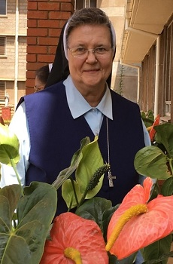
In January of 1998, Sister Mary Annete Adams from Christ the King Province in Chardon arrived, was welcomed by the parish and given her pet name of Abwooli. Now all was in readiness, at least almost, to open the new school year. After Sister settled in, the Sisters went to our school to spur on the workers since our boarders would soon arrive. Being in Buseesa, without easy access to roads, etc., meant that our students would all be boarders. Starting small, the Sisters began with only 1 class of students in P3 that is “Grade 3.” Each year a new Class 3 was added and that was the beginning of so much more that followed.

Opening the school in 1998 with Sister Jane Marie as the first Head Teacher was a great new beginning. The school continued to grow under her leadership and soon St. Julie’s School had a waiting list for entrance. There were many challenges with having small children as boarders, but the

wagon O July 2020 Newsletter Part II Volume 12 #2 Page 4
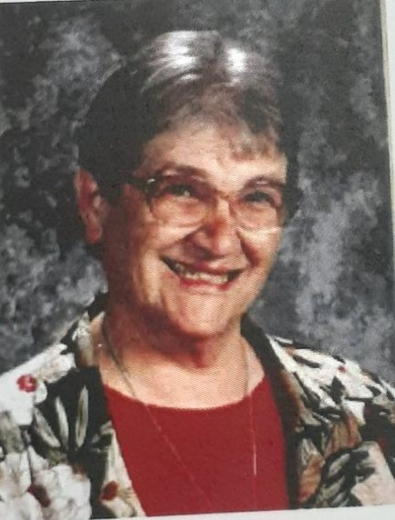
challenge was met. Great teachers helped make a name for the school.
After Sister Jane Marie returned to the States, the school continued under
the leadership of Sister Cristina Marie, then Sister Mary Paulynne, followed
by Sister Mary Colette and now Sister Mary Rozaria Katusabe. A nursery
school was also added to the existing school with Sisters Mary Juliet Namata
as Head Teacher, followed by Sister Mary Sunday and now Sister
Sicholastica Marie is the Head Teacher.

Within the next few years, the Sisters visited schools and parishes and began the Come and See Programme to welcome young women to join our Congregation. As Formator, Sister Mary Annete welcomed our first Candidates in formation in 2001, and in 2004 travelled with them to Tanzania to begin their Postulancy; this led to so much growth in our mission. Beginning with our first few Candidates in 2001, we now have in 2020 a total of nine Senior Professed from Uganda, 17 Temporary Professed, nine Novices and five Postulants. God has really blessed all our efforts in vocation promotion and sustained our Sisters in their vocation. From our school, four young men were ordained Priests in the Hoima Diocese, two young women from our school became Sisters of Notre Dame and one young woman joined the Daughters of St. Therese of the Child Jesus known as the Banyatereza Sisters.

How could we not rejoice at this time of our 25th Anniversary of beginning in Uganda! In 2001, Sister Mary Paulynne Tubick arrived from Thousand Oaks, California and Sister Maria Bernarde from Muelhausen, Germany. Then in 2002, Sisters Mary Rita Geoppinger and Anita Marie Stacy arrived from Covington, Kentucky. In 2006, Sisters Mary Judith Averbeck arrived from Covington and Antoinette Marie Moon from California. This increase in missionaries did much to enhance the programme in our school and mission and gave an impetus to begin leadership training among our African Sisters.
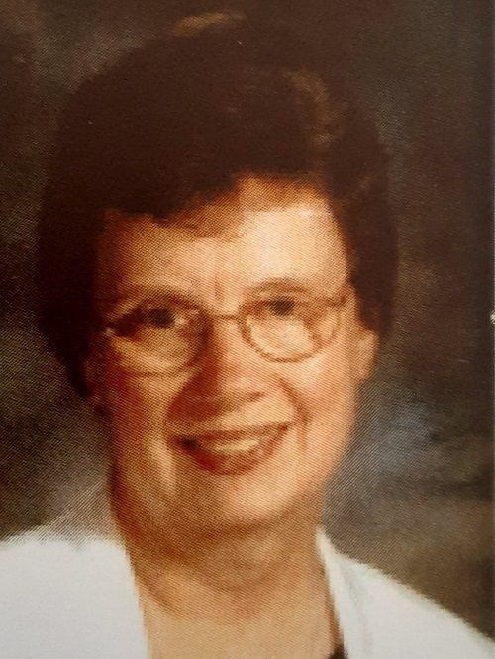
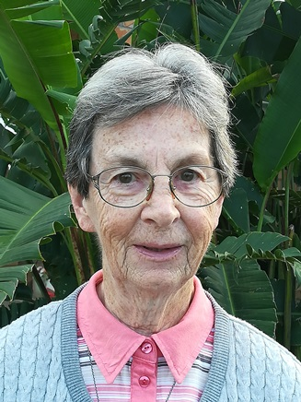
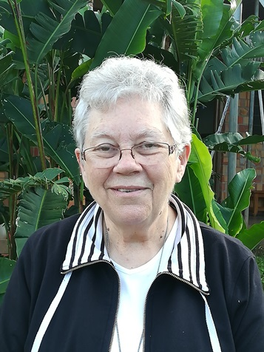
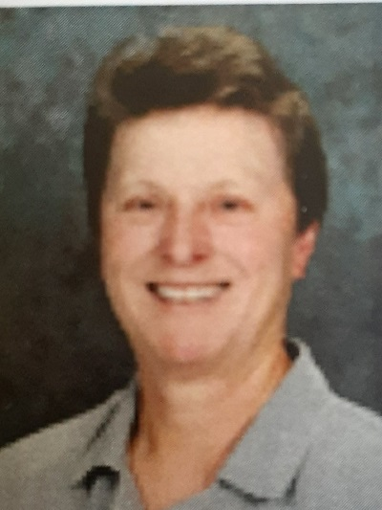

Sister Mary Paulynne Sister Mary Judith Sister Antoinette Marie Sister Maria Bernarde
Our Notre Dame Academy opened in 2003 in Buseesa, Uganda with students in their O Level under the leadership of Sister Mary Rita Geoppinger
and by 2019, we opened our A Level with the new wing construction. These academic years were under the leadership of Sister Anita Marie Stacy.

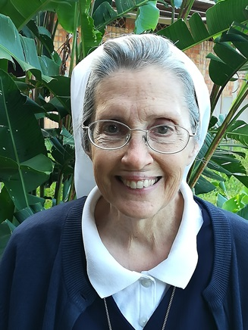
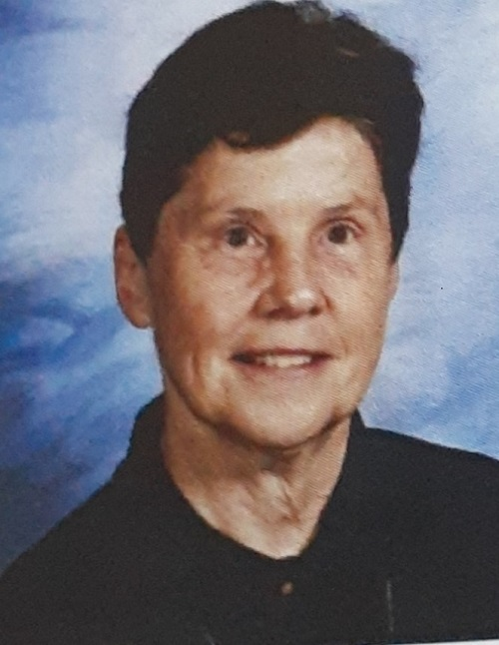

Our new convent was opened in April of 2009 in Lyamutundwe/Mpala, Uganda and became the house of studies for our student Sisters.

wagon O July 2020 Newsletter Part II Volume 12 #2 Page 5
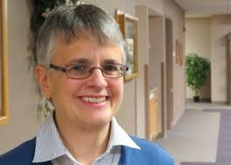
By 2014, with the arrival of Sister Mary Tina Petrick from the
Province of Mary Immaculate, Toledo, Ohio, our Notre Dame Nursery
School began. What a tremendous impact this little school had on our
mission, and the great work that Sister Mary Tina did made it shine!
When Sister Mary Tina returned to the States, the nursery school
continues under the leadership of Sister Mary Annet Namakula.

With the beginning of a joined Unit, including Uganda, Kenya and
Tanzania, our vocations increased and we could offer so much more to the people of God in all three countries. What joy we will have in 2020 as our new administrative team of the Sisters of Notre Dame will be from among our African Sisters

Surely this short history does not say it all, but coming to visit us will help you have a better understanding of the life and culture of these wonderful people. We want to thank all our Sisters who played such an important role in bringing our Uganda mission to fruition and for all our African Sisters who will continue the legacy begun in 1995.
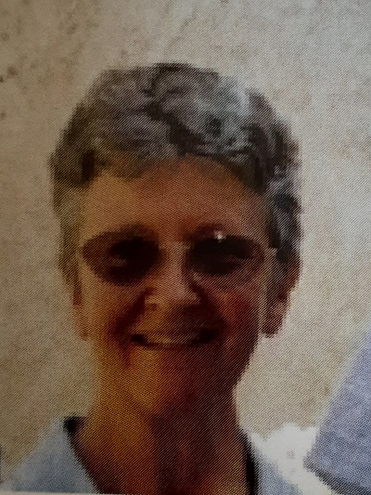
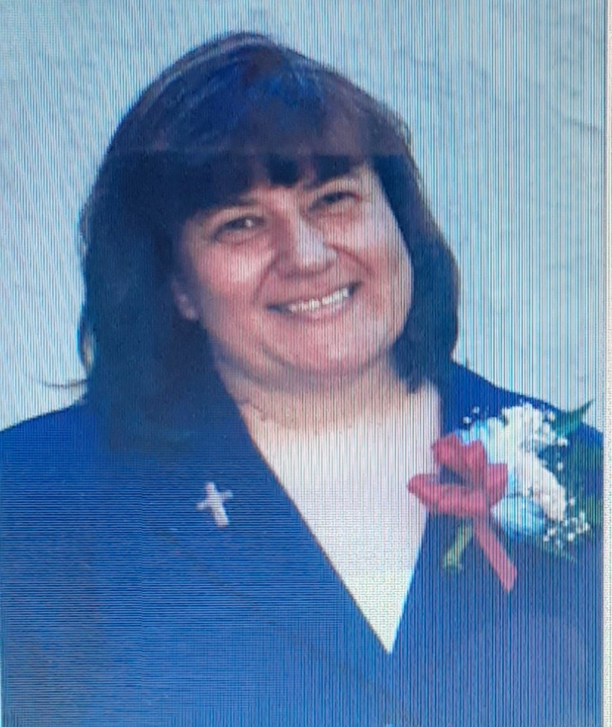
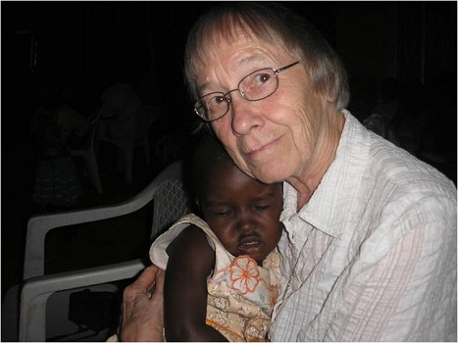
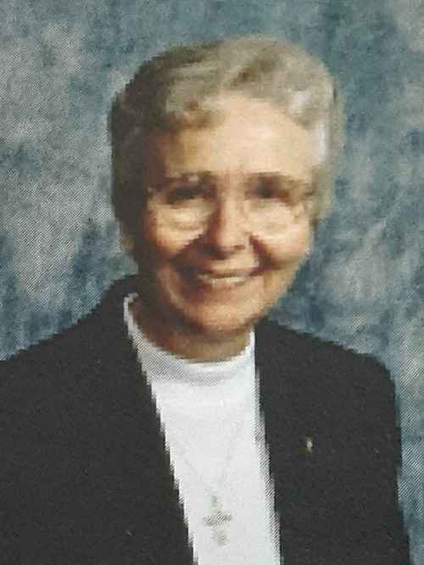

Sister Cristina Marie Sister Maria Ruthilde Sister Mary Regina Sister Mary Bernadette

Since beginning in 1995, the following Provincial Superiors, including Sisters Mary Margaret Droege and Amy Hauck who are pictured on the first page, have given tremendous support and leadership to the mission.
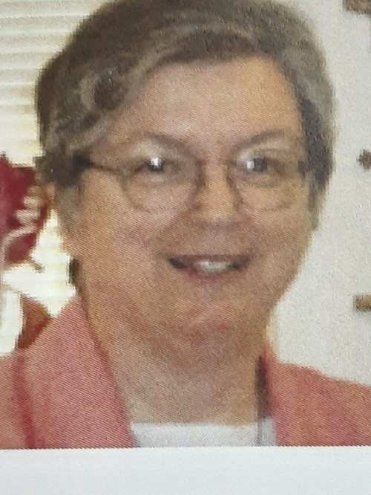
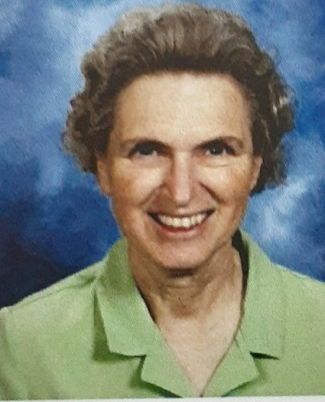
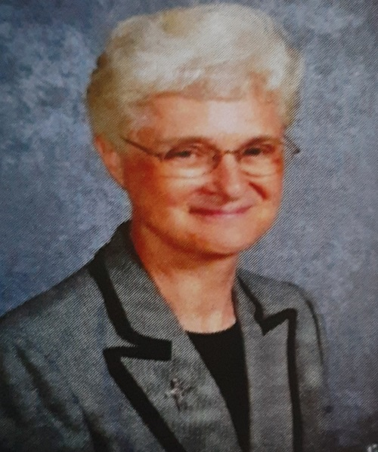

Sister Mary Anncarla
Costello
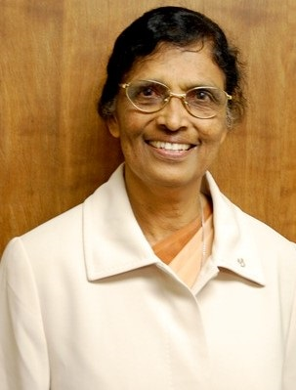
Sister Mary Shauna Bankemper Sister Mary Ethel Parrott

After Sister Mary Joell completed her term of office,
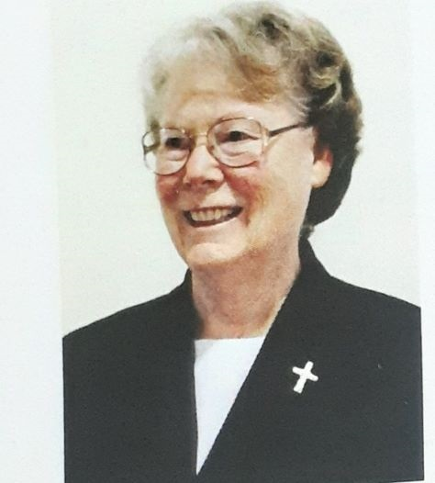

Sister Mary Sujita was the next Superior General
and was very supported of the mission. While Sister
Mary Kristin was one of the Provincial Superiors
during the time of the mission and gave tremendous
support to the mission, she is presently our Superior
General and continues with her supportive leadership.

Sister Mary Sujita
Sister Mary Kristin

wagon O July 2020 Newsletter Part II Volume 12 #2 Page 6

On the day of celebrating the 25th Anniversary, the Parish Priest in Buseesa, Uganda, Fr. Godfrey Tuhairwe, offered a special Mass for the Sisters and gave a wonderful homily about the gift of the Sisters of Notre Dame and their ministry to the parish, school and surrounding area.
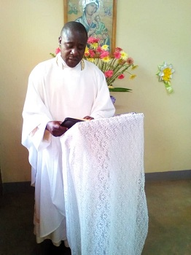

The Sisters, both in Buseesa and Lyamutundwe/Mpala, had a grand celebration recalling the various Sisters who touched their lives, the growth of the mission and so much more. All they had to do was look around to see the contributions of the missionaries and their own contributions to the growth of the mission in Uganda.
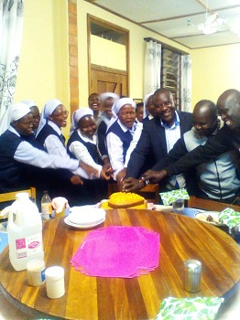
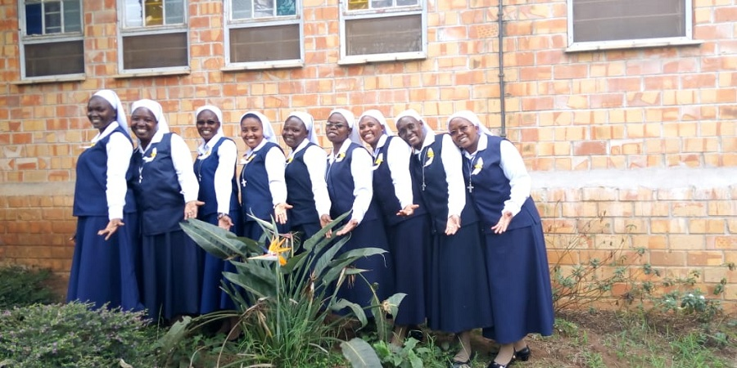

The Postulants and Candidates joined in the
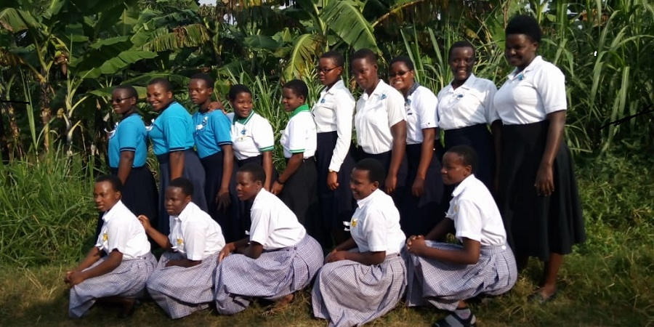
celebration and we are grateful to Sister Mary
Prerna who is their formator and helps them
begin to live the legacy of Notre Dame.
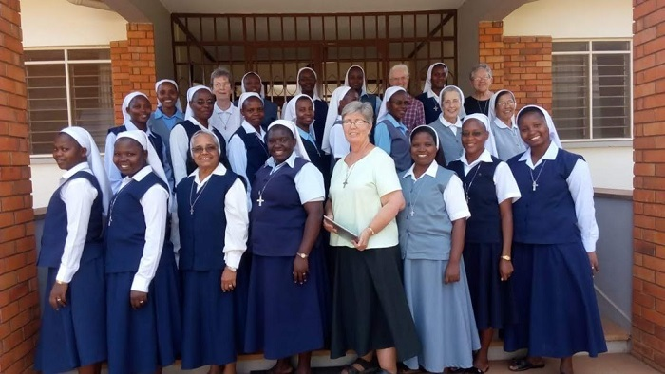

Many others Sisters came over the years as part of their sabbatical, to help with formation, to give retreats, to instruct the teachers on our Notre Dame Heritage and new learnings or as part of Sisters Without Borders Programme.
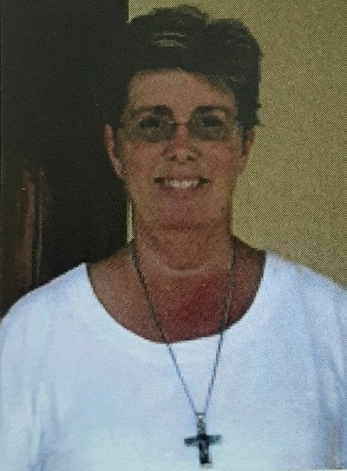
We thank Sister Mary Colette in a special way for all she has done as
Head Teacher, Director of Temporary Professed, Assistant to the
Delegation Superior and so much more. We thank our Good and
Provident God for all the graces and blessings from the beginning of the
mission until now. Thank you is not enough but for now, we
offer a huge THANK YOU to all who have been a part of our life
and ministry in Uganda. May God bless each one.

